## Prerequisite

* Visual Studio 2019 (.net core framework 3.x)
* Need node installed
* Need postman client to test API. (if want to quickly test API)

## Steps to Download and run the API/UI project

1. Go to <https://github.com/swati0402/LetsSearch> and either download zip or clone it from path <https://github.com/swati0402/LetsSearch.git>
2. Open **TechLibrary.sln**

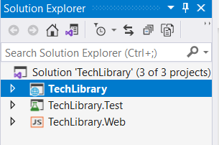

1. Right Click the project “TechLibrary.Web”, select “Open Command Prompt Here”
2. $ npm install *(install the vue js client npm packages)*
3. $ npm run serve *(run the client on localhost)*
4. **F5** in Visual Studio to launch the API project in Debug mode
5. Select “Yes” to the dialog prompt to “trust the ASP.NET Core SSL certificate”
6. In browser type “http://localhost:8000/” and enter. You will be redirected to home page as below.

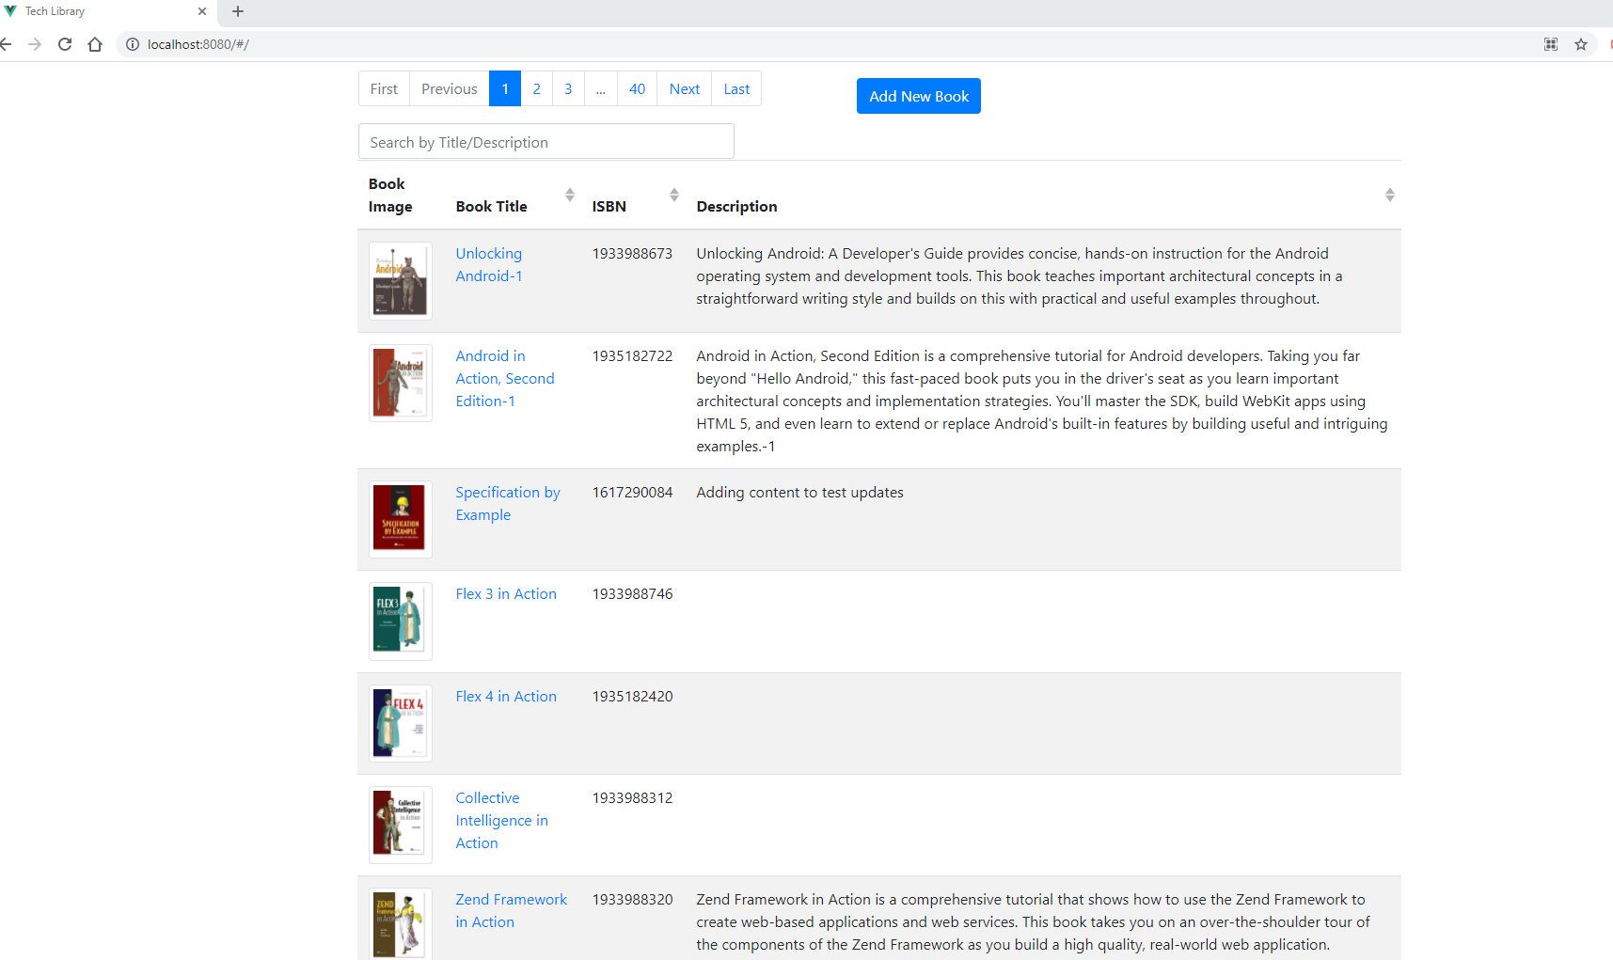

## Steps to validate API/UI project

### Validate from PostMan

1. TechLibrary.postman_collection.json file is attached in email. Once project is running as described earlier: UI on port 8000 and API on post 5001,

Open Postman client and import this file to validate all api controllers’ methods.

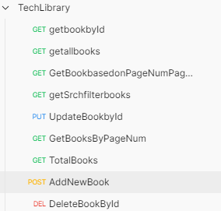

1. Application pages
   * 1. **Home page (book List)**

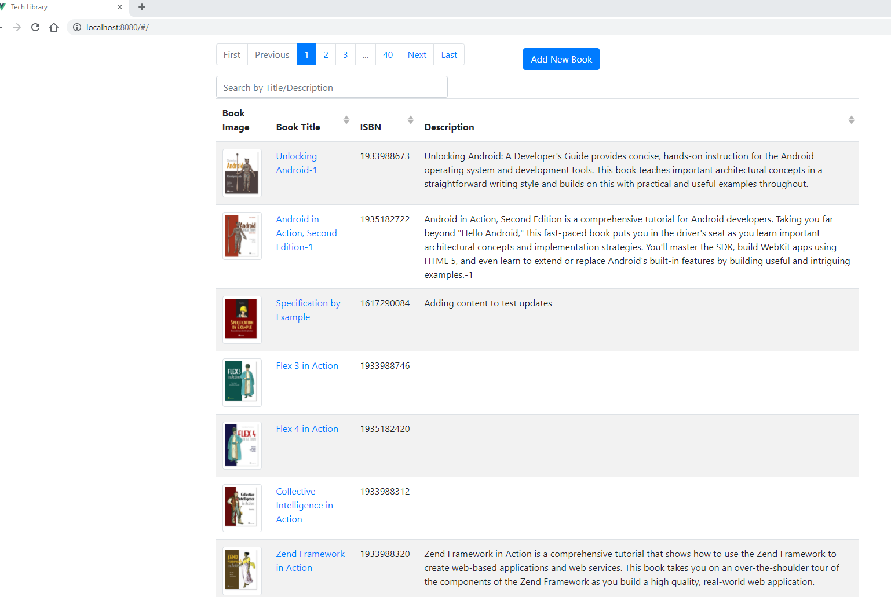

It contains list of first 10 books by default.

Pagination button to go to next/previous pages.

Search box which filter results based on Title or Description. Its case sensitive.

Book tile is a link which will redirect to book details page.

It has Add New Book button to Add new book.

* + 1. **Pagination**

Click on pagenum, next/last, first/previous buttons to go to pages you want to navigate to.

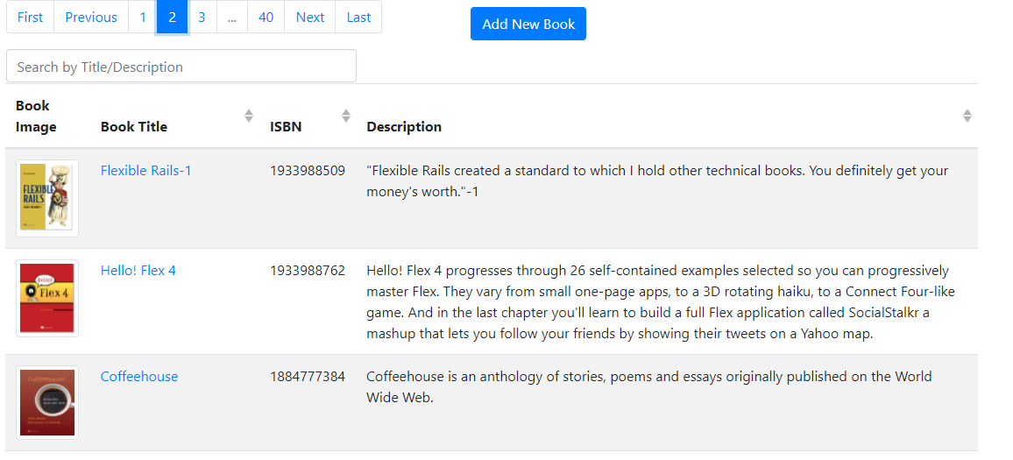

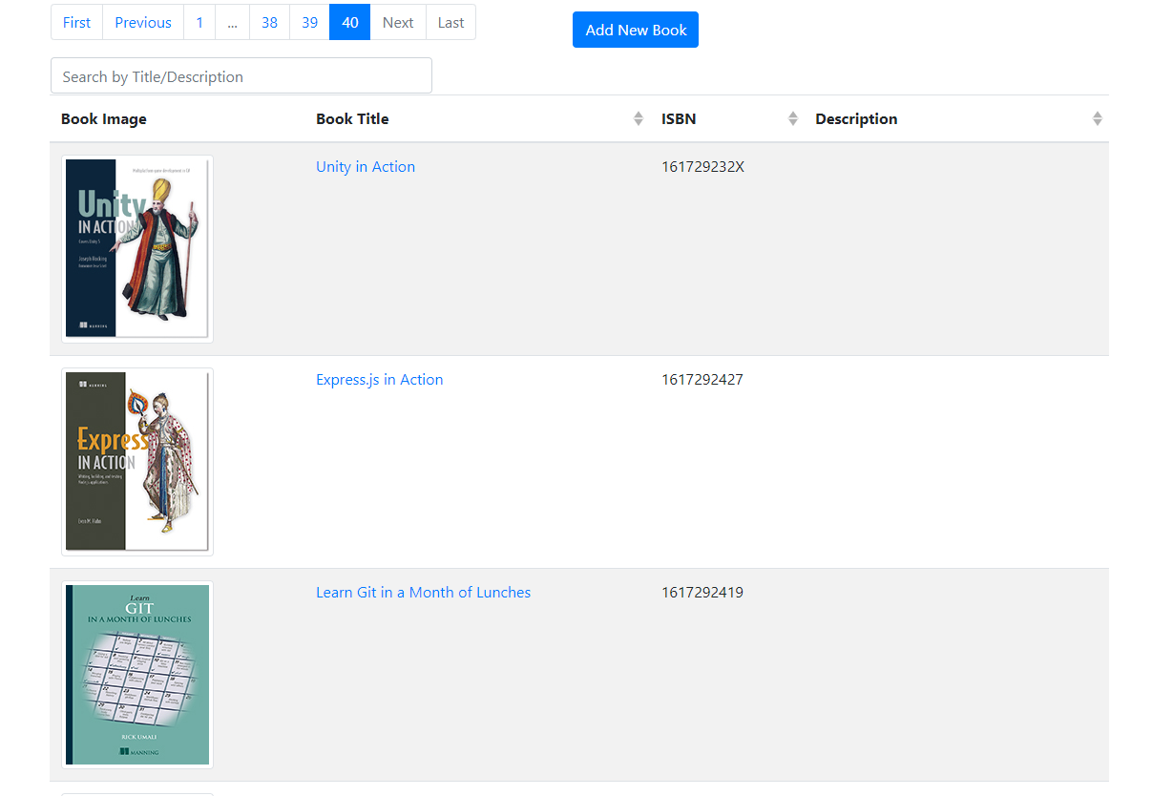

* + 1. **Search/Filter books**

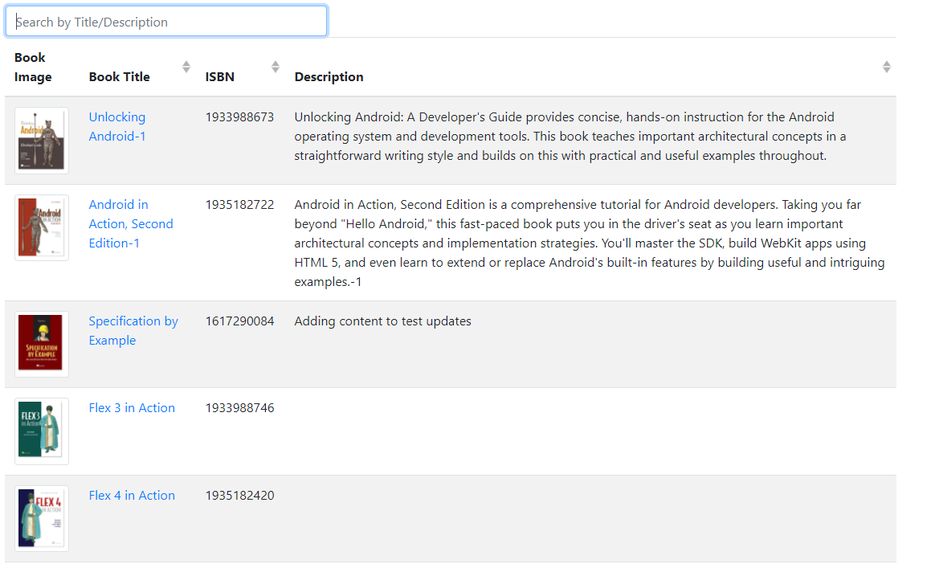

Add text you want to search and will filtered

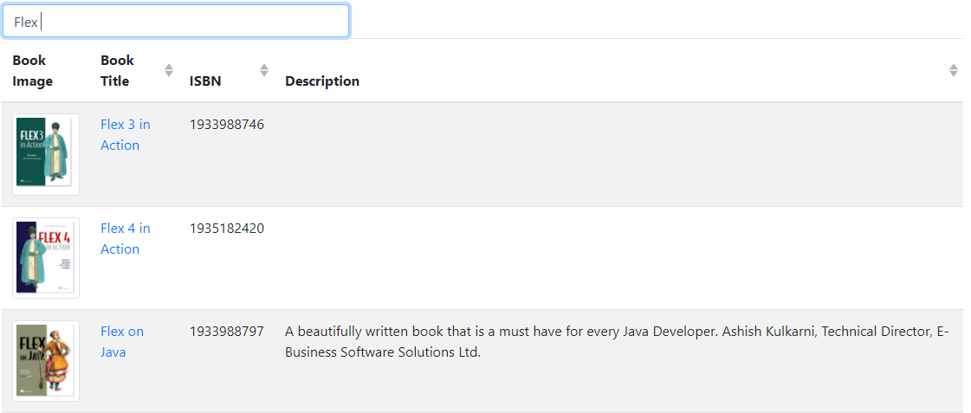

* + 1. **Edit Book Details**

Click on book title to see book details.

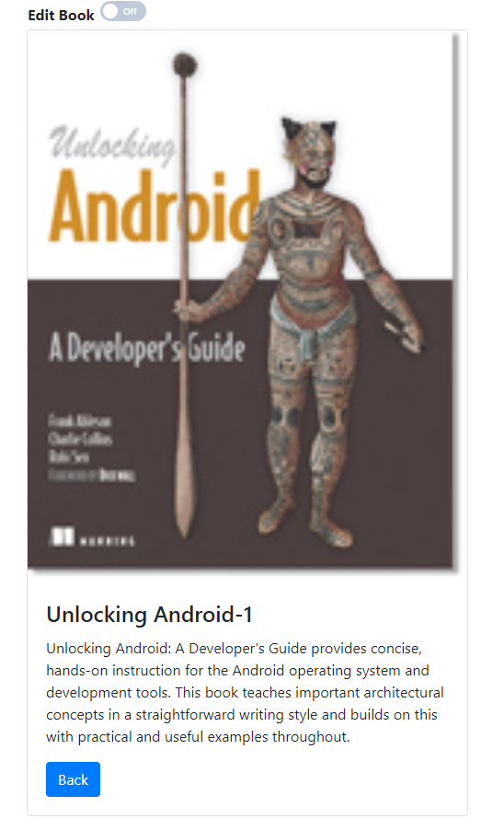

By default, page will be in read only mode and toggle button will be off.Click on toggle button to make edit book records.

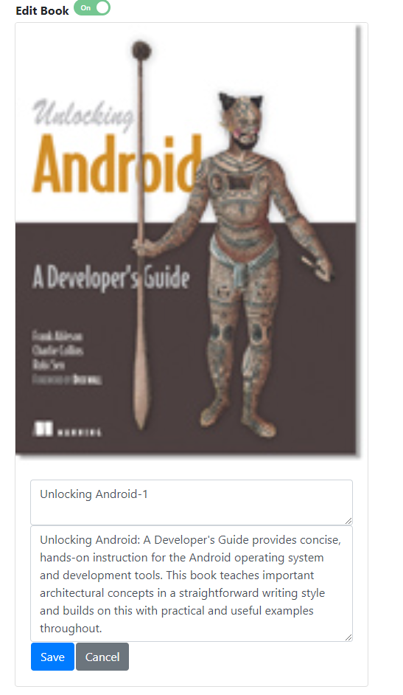

Note: For now, we are providing functionality to edit book Title and description. But this can be enhanced later.

Add/update title description, if you are not sure you want to edit. You can click cancel. button and form will be back in readonly mode.

Add/update title description and click save to save updated records.

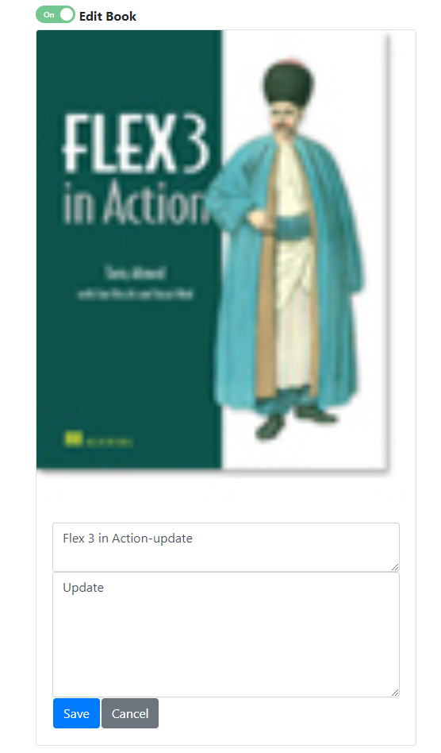

Record will be saved.

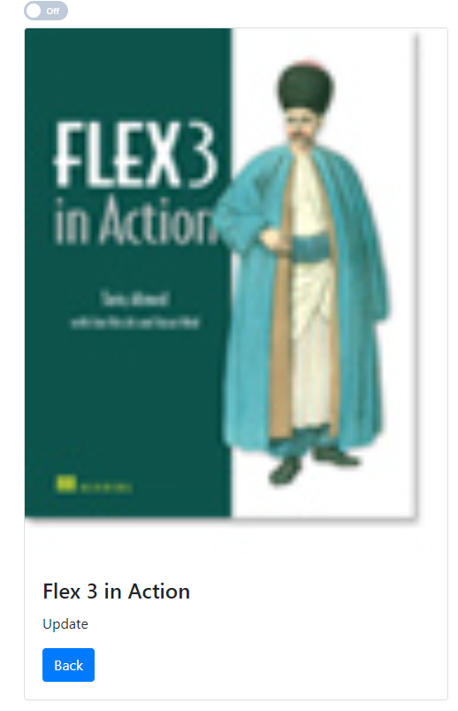

Click back and verify result on main page.



* + 1. **Add Book**

Click on Add new Book button on Home page to go to, Add new book page.

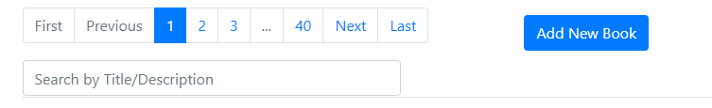

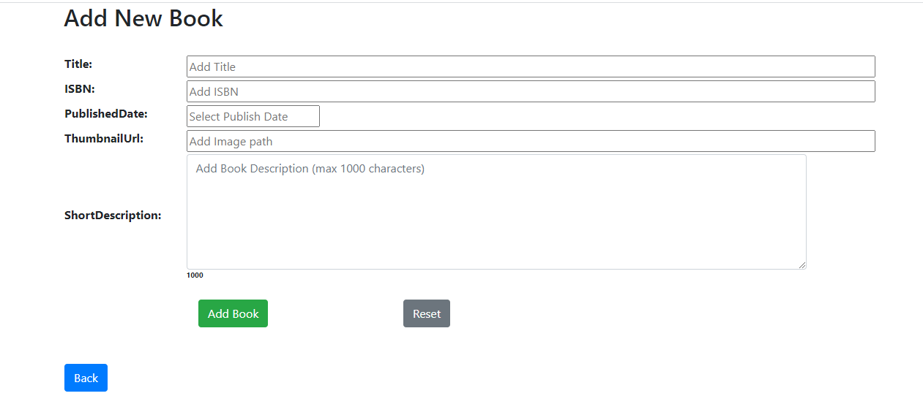

This page has following fields:

Title: Add book title. This is required field.

ISBN: Add book ISBN number

Published date: Select publish date from calendar.

ThumbnailUrl: Add imagepath.

ShortDescription: Add book short description.

Add Book button: will add book in DB

Reset button: will clear the form

Back button: Will redirect back to home page.

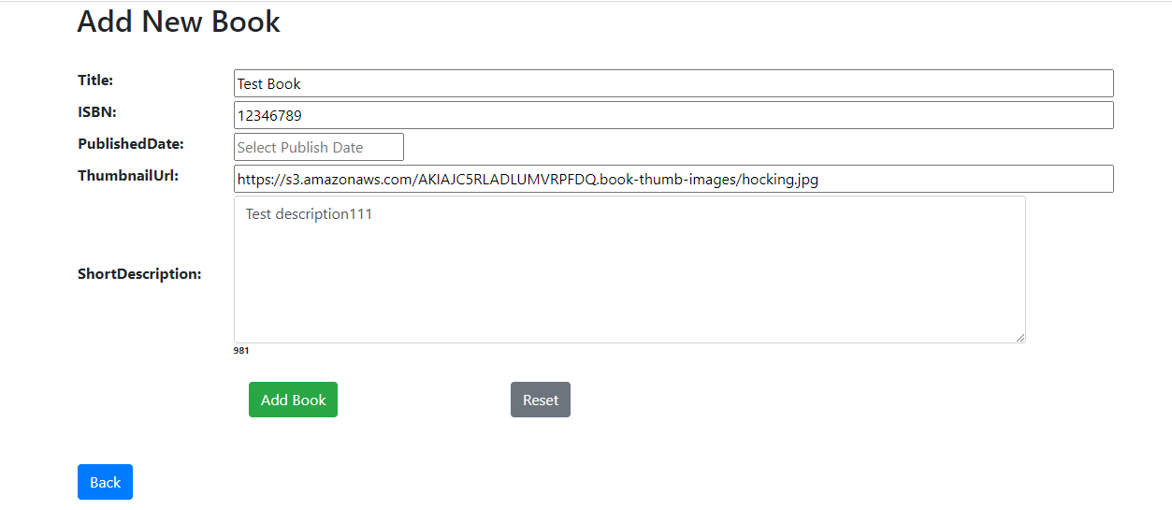

Add validate data and click Add book button. It will save data to Db and add show message.